Your name and your student number: Jeremy van Gorp, 232189

Your mentor: Myrthe

The student number of the person you are reviewing: 232969

Your mentor will give you the masks you need to review (15 masks from one student). Find the images corresponding to these masks from the Y2B_24 dataset. Run the [**task_1_requirements.ipynb**](https://github.com/BredaUniversityADSAI/2024-25-Y2-BlockB/blob/main/datalab_tasks/task1/task_1_requirements.ipynb) notebook to check if the labels satisfy the requirements. Note down your feedback in the format provided below. For requirements 1-4, check whether the tests pass or not. For failing tests, note down the reason briefly. For requirement 5, list all the mistakes you detect.

Question 1. The student submitted 15 masks: Yes/No, if no, list the missing masks.

1. Name of the image file: **val_Myrthe_232969_im1.png**

|  |  |  |  |
| --- | --- | --- | --- |
|  | Shoot Mask | Seed Mask | Root Mask |
| **Req 1** | PASS | PASS | PASS |
| **Req 2** | PASS | PASS | PASS |
| **Req 3** | PASS | PASS | PASS |
| **Req 4** | PASS | PASS | PASS |

**Requirement 5** To assess the label quality, you need to overlay 3 masks with 3 different colors onto the image. The code to achieve this is in the [**task_1_requirements.ipynb**](https://github.com/BredaUniversityADSAI/2024-25-Y2-BlockB/blob/main/datalab_tasks/task1/task_1_requirements.ipynb) notebook. Use screenshots from the overlay with arrows to indicate the locations of the errors. Note that your peers should be able to find the error, so describe the location of the error as clearly as possible.

**Note:** If a requirement from 1-4 fails, you might need to fix the issue before plotting the overlay. For example, the masks must be binary with pixel values 0 or 1. If the submitted mask is binary but the pixel values are 0 or 255. Before plotting the overlay image, you need to normalize the mask to 0-1.

Here are some error types:

* **Missed Roots** - Roots that should be labeled are not labeled.
* **Incorrect Root Labeling** - Non-root areas are labeled as roots.
* **Missed Seeds** - Seeds that should be labeled are not labeled.
* **Incorrect Seed Labeling** - Non-seed areas are labeled as seeds.
* **Missed Shoots** - Shoots that should be labeled are not labeled.
* **Incorrect Shoot Labeling** - Non-shoot areas are labeled as shoots.
* **Incorrect Root Border** – Roots are labeled thicker/thinner than they actually are.
* **Other Miscellaneous Labeling Errors** - Any other errors not covered by the above types.

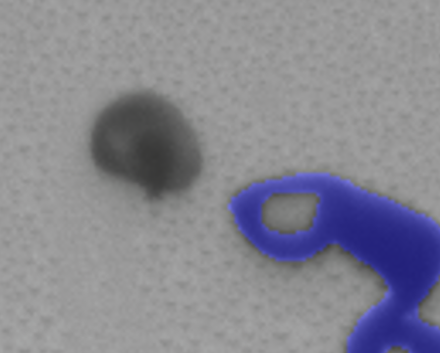 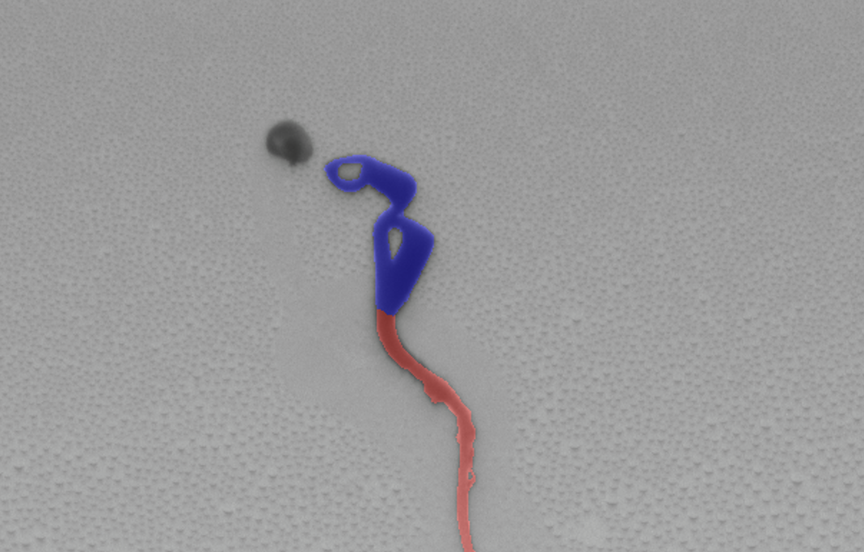

**Requirement 5:**Missed Seeds - Seeds that should be labeled are not labeled.  
  
**Note:**  
This could be the case if you forgot to fill in the seed or if you checked it with a mentor to confirm whether it was a seed. If you have not discussed this with peers or mentors, make sure to do so to confirm its status.

1. Name of the image file: **val_Myrthe_232969_im2.png**

|  |  |  |  |
| --- | --- | --- | --- |
|  | Shoot Mask | Seed Mask | Root Mask |
| **Req 1** | PASS | PASS | PASS |
| **Req 2** | PASS | PASS | PASS |
| **Req 3** | PASS | PASS | PASS |
| **Req 4** | PASS | PASS | PASS |

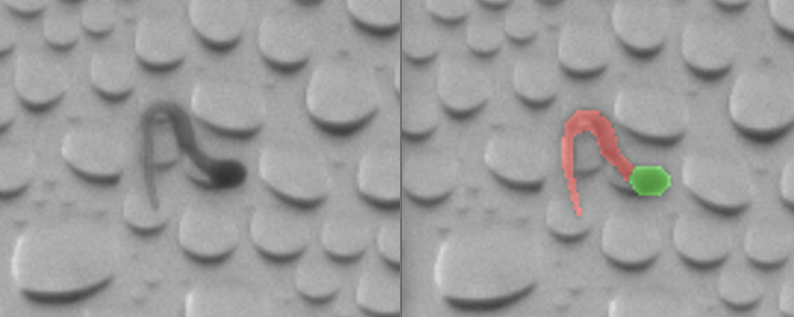 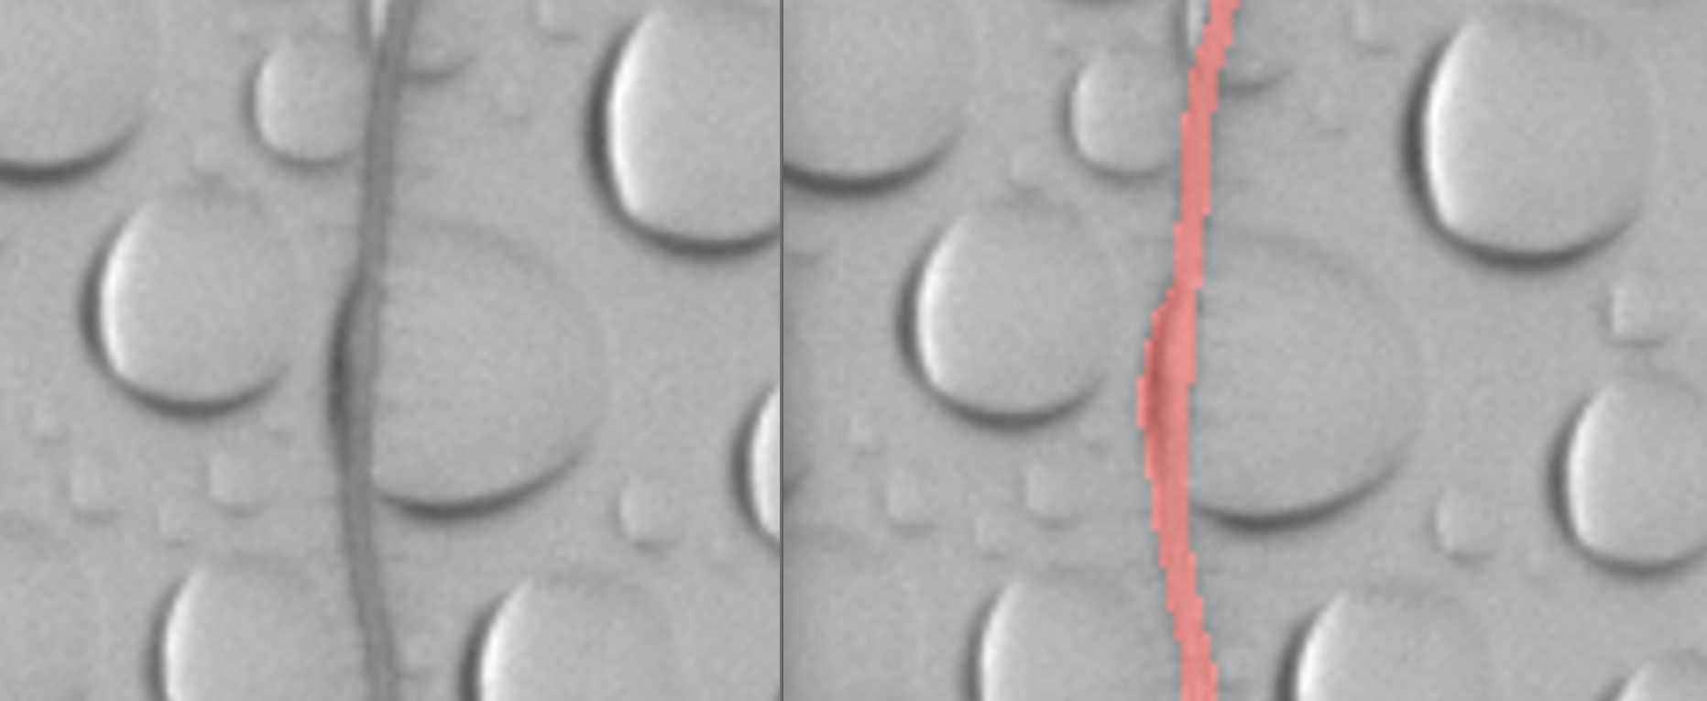

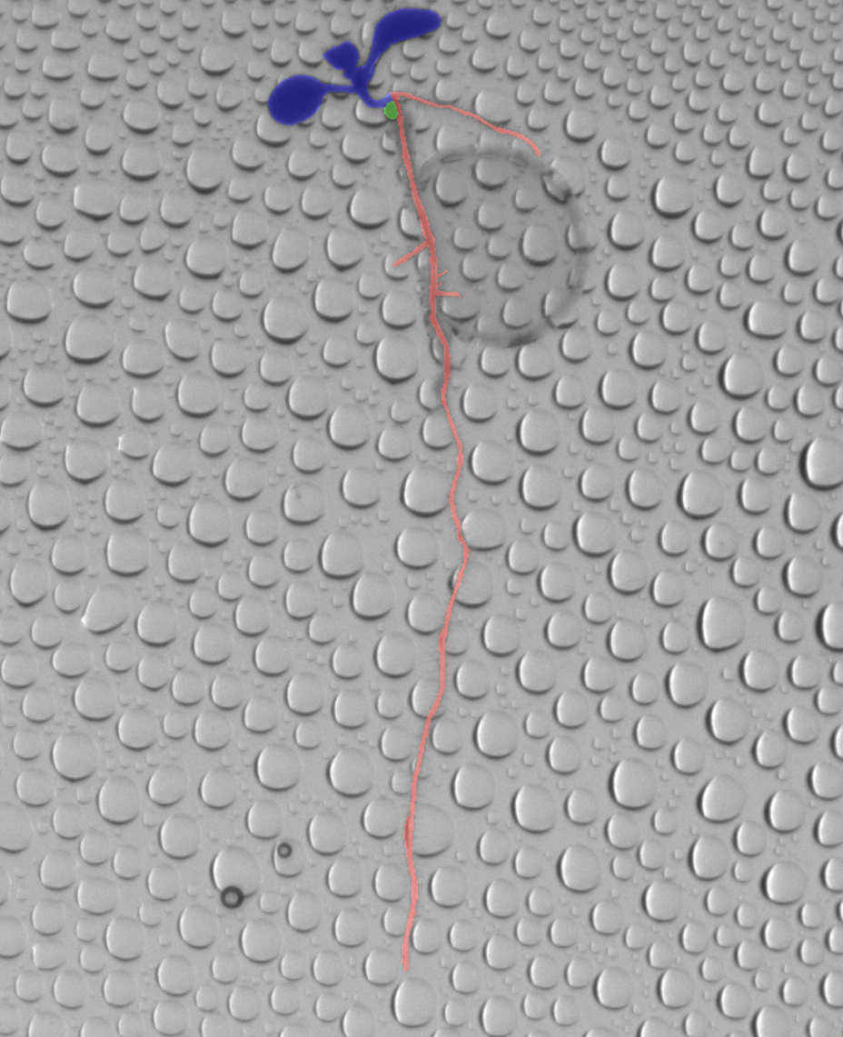 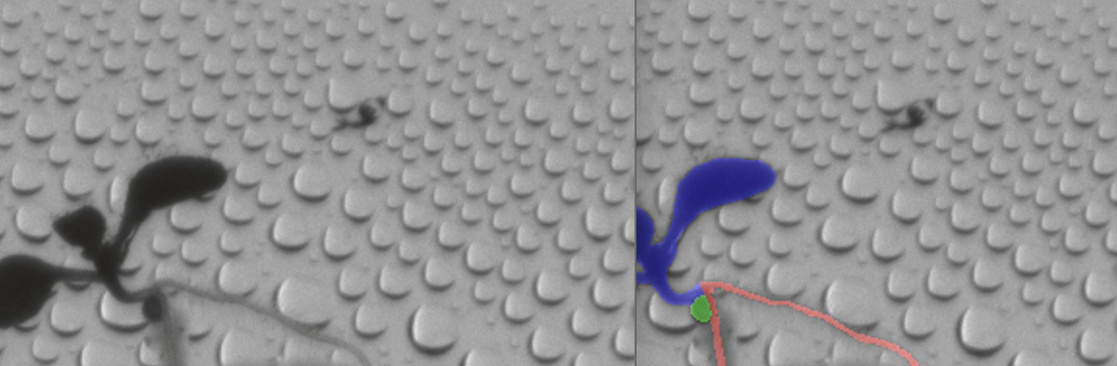

**Requirement 5:**

Incorrect Root Border – Roots are labeled thicker/thinner than they actually are.

**Note:**

In the first picture, there was a minor mistake where a part of a bubble was colored in.

The same applies to the second picture (pictures two and three are related; picture three is zoomed out to help locate the area). In this picture, the rim of the bubble was also colored in. Make sure to use a one-pixel brush and the pencil tool in that specific area.

The last picture might represent a special scenario. In some images, there are more than five seeds, while in others, there may be as few as one. Check this with a mentor to determine what it could signify.

1. Name of the image file: **val_Myrthe_232969_im3.png**

|  |  |  |  |
| --- | --- | --- | --- |
|  | Shoot Mask | Seed Mask | Root Mask |
| **Req 1** | PASS | PASS | PASS |
| **Req 2** | PASS | PASS | PASS |
| **Req 3** | PASS | PASS | PASS |
| **Req 4** | PASS | PASS | PASS |

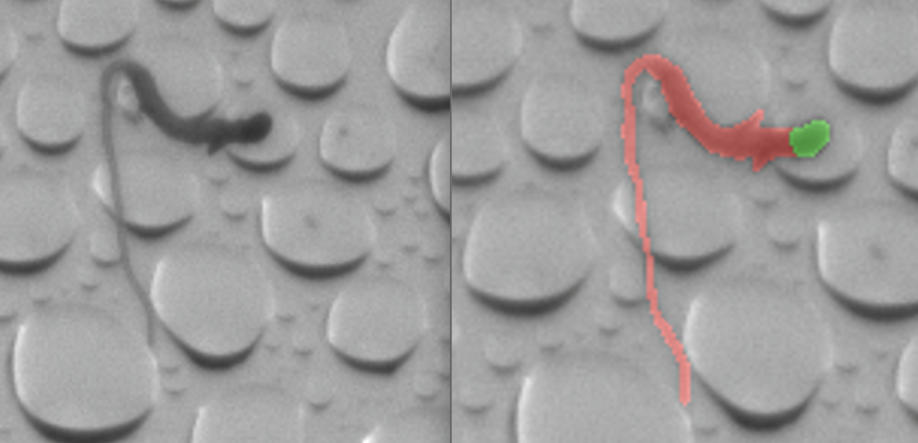

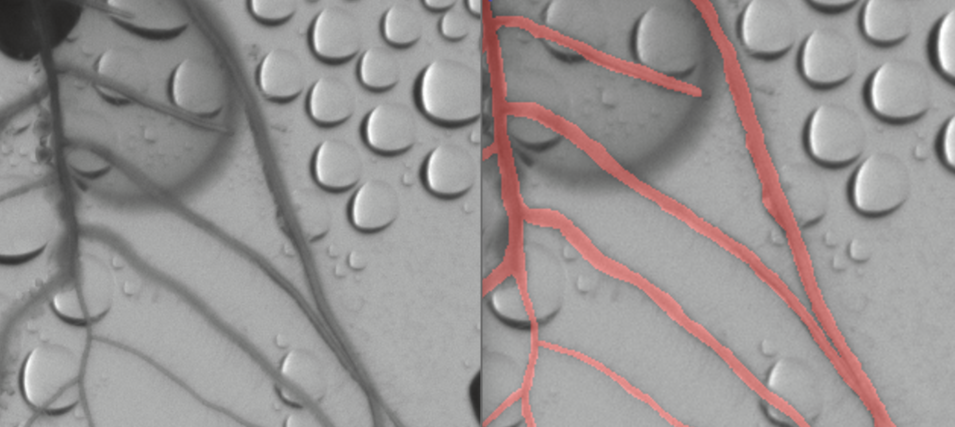

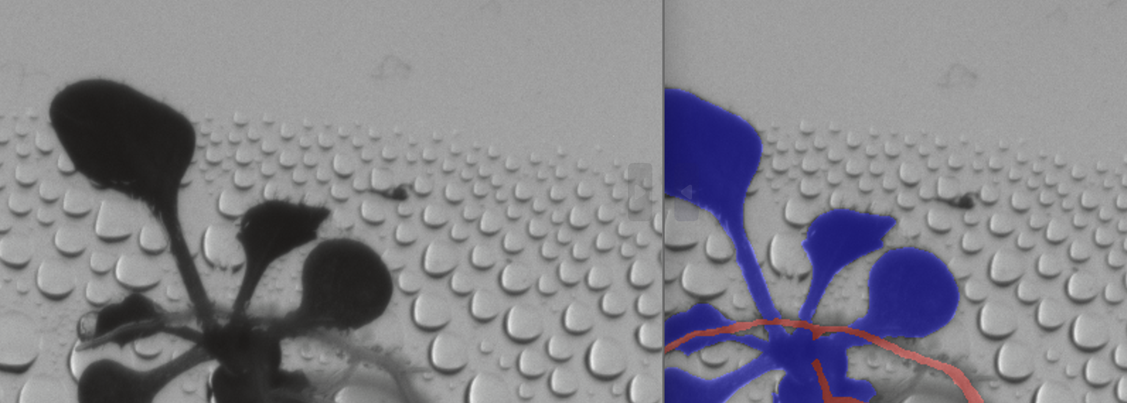

**Requirement 5:**

Missed Shoots - Shoots that should be labeled are not labeled.

Incorrect Root Border – Roots are labeled thicker/thinner than they actually are.

**Note:**

In the first picture, the thicker part, when the plant is in this state, should mostly be labeled as a shoot.

In the second picture, the rim of the bubble has been colored in.

For the last picture, check with a mentor to confirm whether this is a seed or not.

1. Name of the image file: **val_Myrthe_232969_im4.png**

|  |  |  |  |
| --- | --- | --- | --- |
|  | Shoot Mask | Seed Mask | Root Mask |
| **Req 1** | PASS | PASS | PASS |
| **Req 2** | PASS | PASS | PASS |
| **Req 3** | PASS | PASS | PASS |
| **Req 4** | PASS | PASS | PASS |

**Requirement 5:**

**Note:**

Correctly colored in, nothing to add.

1. Name of the image file: **val_Myrthe_232969_im5.png**

|  |  |  |  |
| --- | --- | --- | --- |
|  | Shoot Mask | Seed Mask | Root Mask |
| **Req 1** | PASS | PASS | PASS |
| **Req 2** | PASS | PASS | PASS |
| **Req 3** | PASS | PASS | PASS |
| **Req 4** | PASS | PASS | PASS |

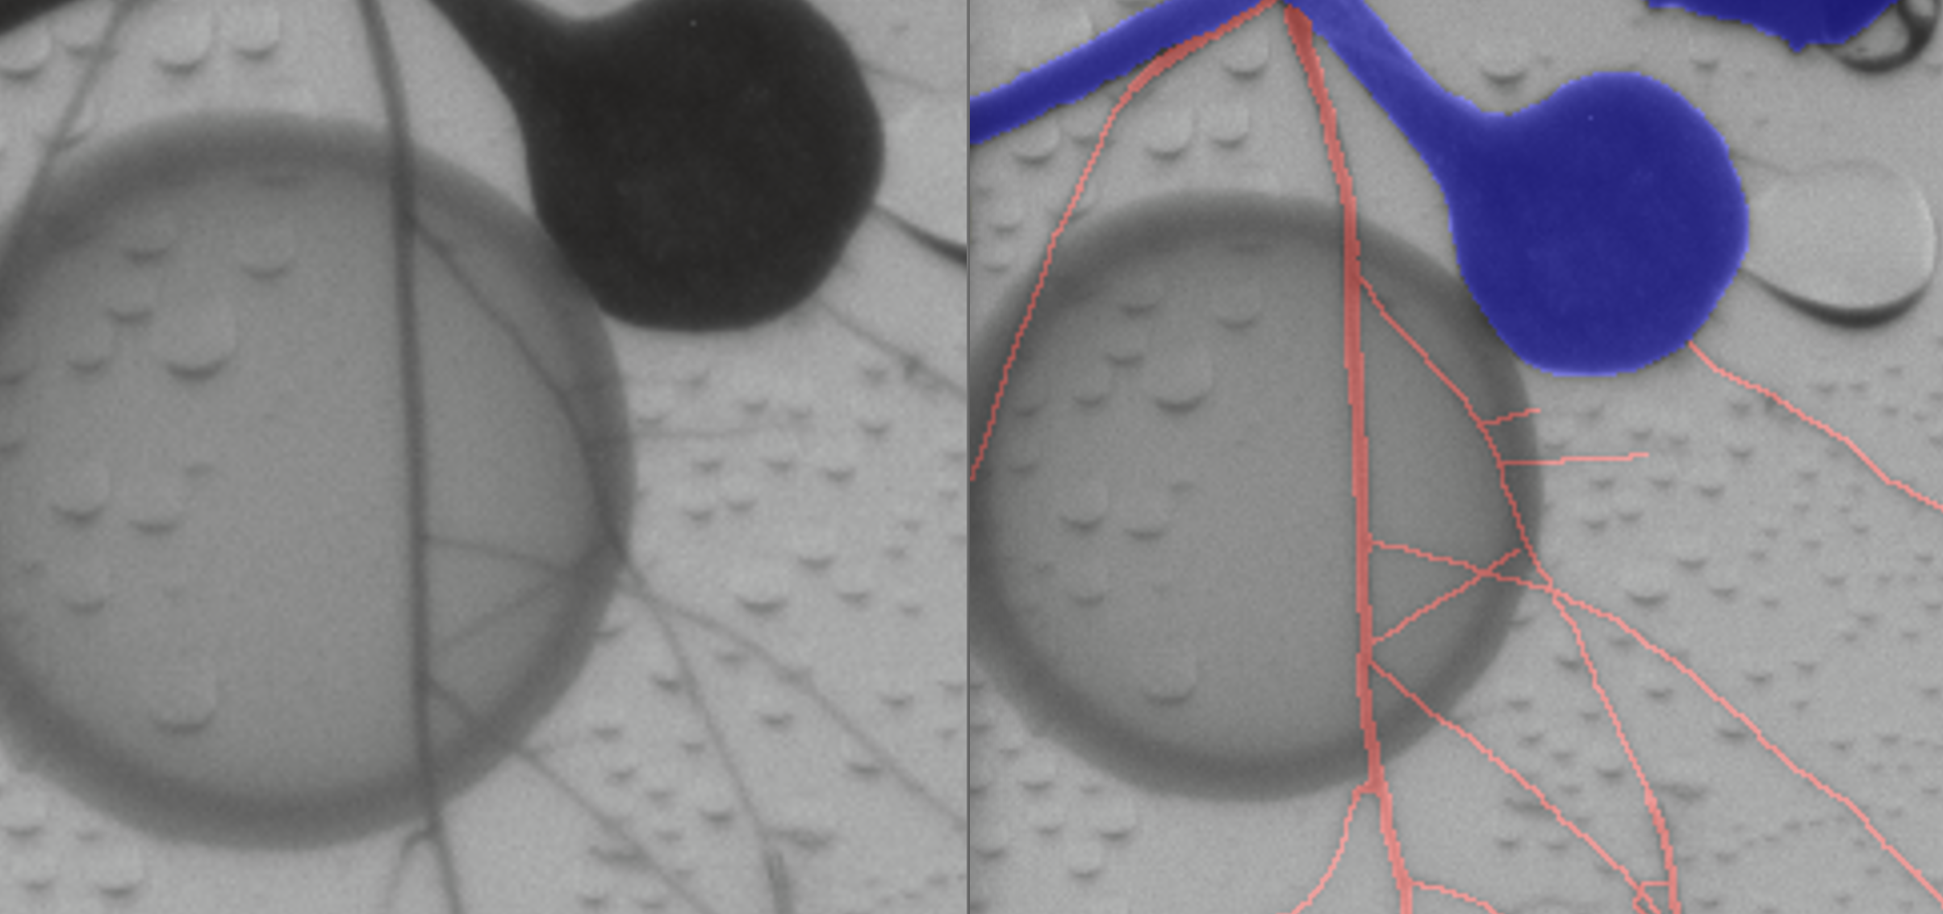 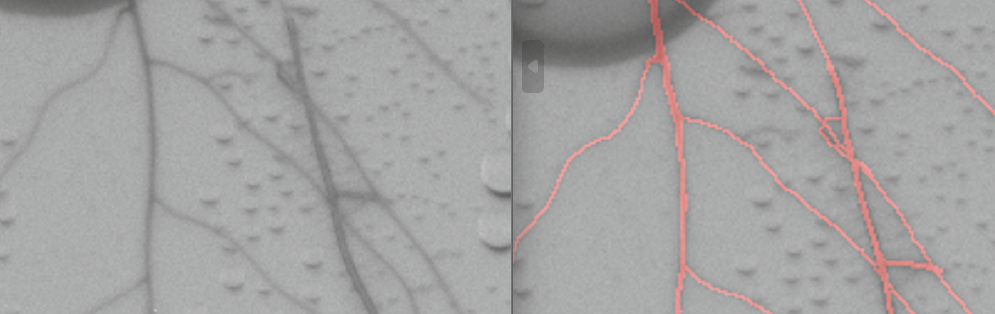 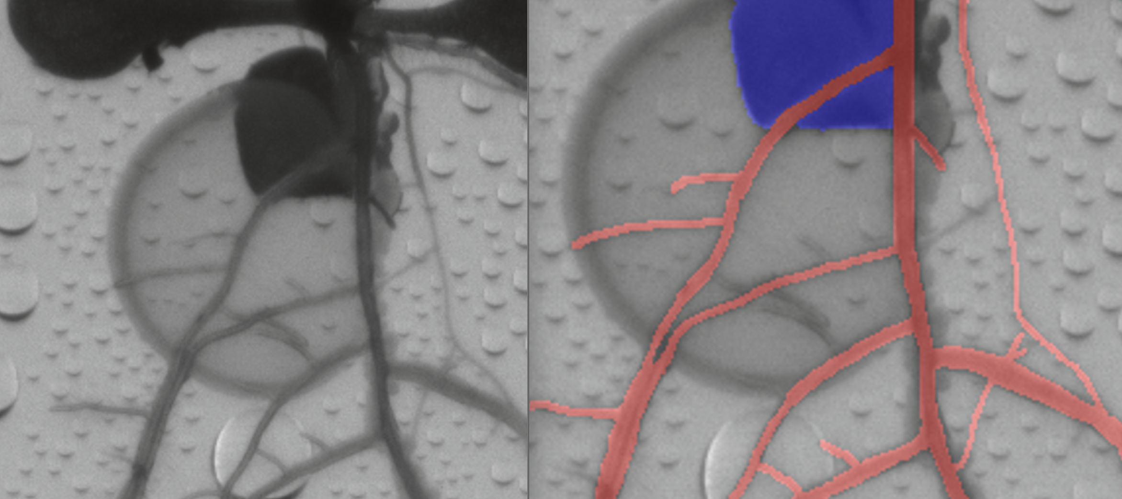 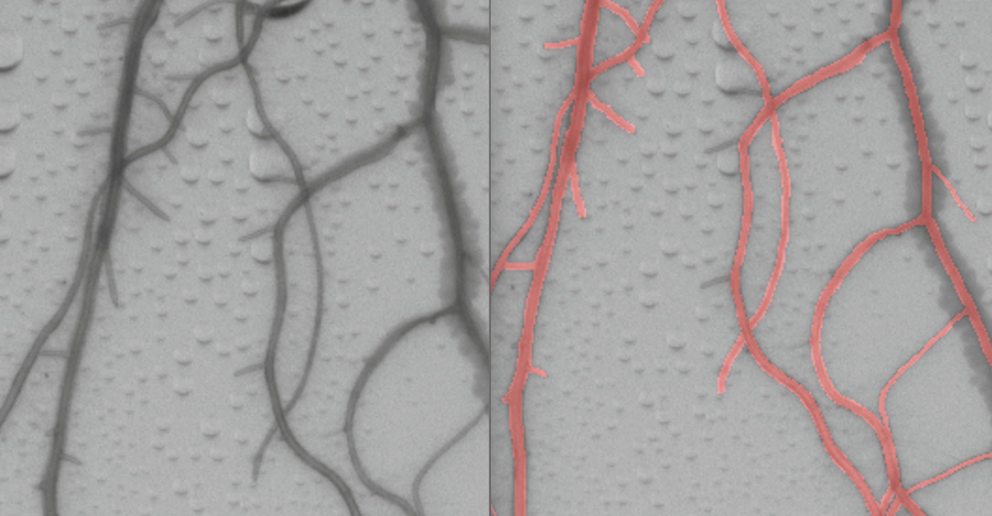

**Requirement 5:**

Missed Roots - Roots that should be labeled are not labeled.

**Note:**

In all the pictures, some roots are missing. While they may be difficult to see when zoomed in, they become easier to spot when zoomed out. Use the pointed arrows as a guide to fill in the missing roots.